Understanding Conflict in the Philippines
A Spatio-Temporal Analysis

Noah Berkowitz
nberkowitz@clarku.edu

Gabriel Yarleque Ipanaque
jyarlequeipanaque@clarku.edu

Abstract:

The identification of conflict incidents can provide humanitarian organizations with information to assist Internally Displaced People (IDP) and develop plans to mitigate the impact of these incidents, especially at-risk populations like children. This analysis identified spatial and temporal patterns of conflict in the Philippines for the year 2017. Conflict incidents are widely distributed throughout the country. The conflict in the City of Marawi (May 23rd to October 23rd, 2017), located in the Lanao del Sur province, reported the greatest number of victims when compared to other conflict incidents within the country. Understanding these patterns can help the government and decision-makers in making better decisions and designing policies to ensure the well-being of the citizens. Furthermore, categorical research such as gender or age-based, and better data can diversify the results of this study.

Problem statement/objectives/Lit Review:

According to the Empirical Studies of Conflict Project, “The Philippines is home to some of the most protracted insurgencies in the world” (Felter, 2018). This is the first study focused on understanding the spatial-temporal patterns of conflict in The Philippines (Figure 1). The occurrence of conflict incidents and their characteristics such as target types and number of fatalities change across space and time (Afsar et al., 2014). Previous research used spatial statistics to locate hot spots of terrorist events and to identify future terrorists' trends. Spatio-temporal temporal analysis/patterns are defined as “manifestations of the dynamics of cultural processes across the physical landscape” (Siebeneck et al. 2009). The paper goes further in justifying a spatial-temporal analysis as applied to terrorist activities stating, “analysis of the spatial and temporal patterns of terrorist activities should provide information and insights into the geographic activity spaces” (Siebeneck et al. 2009). These “geographic activity spaces” represent analysis and its applied scope” (Siebeneck et al. 2009).

The country’s conflicts have a lack of depth in terms of geospatial analysis. This paper uses spatial-temporal analysis methods to understand conflict activity/ variation in the Philippines over a one-year period (2017). The paper finds clusters of conflict incidents based on location and number of fatalities. This paper visualizes the impact of conflict activity on the people living on those areas (IDP’s). In the paper, the research compares the effectiveness of spatial analysis methods and visualization techniques.

Data:

Data used in this project was accessed on October 1, 2018. The conflict incident data for The Philippines was downloaded from the Armed Conflict Location & Event Data Project (ACLED) website. The data was in CSV format and it included information on the dates, actors, types of violence, locations, and fatalities of all reported political violence and protest events across the country. Demographic information at the province level and limited number of IDP for 2017 at the municipality level was available from the Humanitarian Data Exchange (HDX) (https://data.humdata.org/) open data repository platform. Administrative boundaries were obtained from PhilGIS (https://www.philgis.org/), the Philippines GIS Data Clearinghouse. The Global Terrorism Database (GTD) (https://www.start.umd.edu/gtd/) provided shapefile based information of terrorist events in the Philippines. After reviewing the conflict incidents and ensuring the data does not overlap, both the GTD and ACLED datasets were selected for this study.

Methods:

Conflict Incident Data Preparation:

Both the ACLED and the GTD datasets were filtered to select only the 2017 incidents. The conflict locations were displayed as points in ArcMap 10.6.1 using the latitude and longitude values. All layers were projected to WGS_1984_UTM_Zone_51N. The analysis was completed using ArcMap 10.6.1 and ArcGIS Pro 2.2. Figure 2 shows the analysis workflow.

Kernel Density Analysis:

Conflict incidents are represented as point locations, and the impact of conflict in a specific region tends to go beyond its exact location in space (Mesev et al., 2009). Kernel density is used to create a smooth raster surface for each conflict dataset based on the number of fatalities reported at each point location. To quantify the overall trend of conflict-related fatalities, both surfaces were added using the raster calculator in ArcMap (Florance et al. 2017). The province boundary was overlaid to delineate the spatial limits of the conflict and define the provinces with the highest fatalities. Kernel density was performed on Mindanao Island to take a closer look at the Battle of Marawi. Province was used as the spatial unit. Thus, to calculate the number of conflict incidents per province, the ACLED dataset was joined to the province layer based on spatial location. The joined dataset was later used to perform spatial autocorrelation.

Spatial autocorrelation:

The Global Moran’s I statistic indicates clustering or other spatial patterns in our dataset. This analysis examines if provinces with a high number of fatalities are closer to other provinces with similar characteristics. Positive Moran’s I value indicates positive spatial autocorrelation where a location is surrounded by other location of high values. Negative Moran’s I value indicates negative spatial autocorrelation, where a location is surrounded by non-similar values. The z-scores determine the statistical significance of the Moran’s I value (Esri, 2018). Z-score values greater than 1.96 indicate a statistically significant spatial autocorrelation (Esri, 2018). The p-value represents the probability that the observed spatial pattern is the result of a random process (Esri, 2018). High z-scores associated with very low p-values rejects the hypothesis that the observed pattern is the result of a random process.

Optimized hot spot analysis:

Optimized hot spot analysis was performed on the ACLED dataset. It finds the specific location and size of patterns based on the number of conflict-related fatalities at each location. Crime researchers used it to understand events and identify patterns over time (Siebeneck et al., 2009). The outcome is a vector-based dataset different from the kernel density analysis.

Spatial-Temporal analysis:

Spatial-Temporal analysis locates clusters of a given phenomenon in space and time simultaneously (Levine, 2006). To perform this analysis, ACLED incidents were aggregated into 15 km x 15 km bins or space-time cubes based on their spatial location, and using a 30-day temporal window in ArcGIS Pro. The space-time cube was used as input to create emerging hot spot analysis. It finds new, intensifying, diminishing, and sporadic hot and cold spot trends based on the location of events (Esri, 2018). The outcome of emerging hot spot analysis was visualized in three dimensions to observe the spatial-temporal patterns of conflict incidents.

Impact of Conflict on IDP:

Information regarding the number of IDP was used to determine the impact of the Battle of Marawi on the local population. This information was collected at the municipality level; therefore, municipalities were used as the spatial unit to identify trends of IDP. Not all municipalities have IDP information. The CSV table was joined to the municipalities layer and population density was calculated. Finally, we created an IDP rate (%) to quantify the percentage of the population displaced from a given municipality because of conflict in Marawi.

Results:

Figure 3 shows the spatial autocorrelation report. The Moran’s Index is - 0.11. The z-score is – 0.22 and the p-value is 0.82. Therefore, given the negative z-score value and the high p-value, there is a 90% likelihood that the pattern does not appear to be significantly different from random. This result is possible because the scale of the analysis is limited to a one-time period. Even though the pattern found is the result of a random event, there is a need to find the specific location of incidents with high and low conflict-related fatalities.

After adding the kernel density surfaces, a hot spot is observed by the Central Capital Region that is out of five ranges the third highest range (Fig. 4). In contrast, the optimized hotspot analysis in the central capital region presents a clear cold spot (Fig. 5). Thus, areas that experience a greater number of conflicts are not necessarily areas with the greatest fatalities. These results show the hot spot in the Lanao del Sur province depicts a strong concentration of conflict-related fatalities. During 2017, there were 1262 fatalities in Lanao del Sur. This location of the Marawi district. However, the negative spatial autocorrelation indicates that the surrounding provinces had a relatively small number of fatalities. This validates the fact that, conflict incidents for 2017 are the result of a random process, and data from the surrounding provinces do not share the same characteristics.

The emerging hot spot analysis reveals clusters of the most persistent conflict incidents through time (Fig. 6). Visualization in three dimensions (Fig. 7) was used to notice that before May 2017, there was no observed trend regarding the number of conflict events on Lanao del Sur. However, after May there was a rapid increased in conflict events. These areas are identified as a consecutive hot spot. An intensifying hot spot is found on the Central Capital Region. This pattern is observed because emerging hot spot analysis considered the number and location of conflict incidents and not the number of fatalities. Cold spots around the study area are very limited. This is the result of very low conflict incidents on those locations through time. The empty bins are locations with one, or less than one event for every time-period. Thus, no pattern could be identified.

Finally, the impact of conflict is measured as the percentage of population being displaced at the municipality level (Fig. 8). The Saguiaran municipality, next to the city of Marawi, has the highest displacement rate. Approximately 85 percent of the total population from this municipality has been displaced because of the Marawi conflict. Figure 9, shows a three-dimensional visualization of the displacement rate at the municipality level.

Conclusion:
This research presented a series of analysis that is useful to understand conflict incidents based on a variety of factors such as event locations and conflict-related fatalities. The results indicate that the Lanao del Sur province, where the Marawi conflict took place, reported the greatest number of victims when compared to other conflict incidents within the country. Conflict incidents are dynamic and change over time. This analysis has demonstrated that conflict hot and cold spots are localized across the landscape.
Performing emerging hot spot analysis on current datasets can help monitor the patterns of conflict across time and space. This helps identify locations where events are emerging or diminishing. It is crucial for humanitarian organizations at the national and international level to develop measures to mitigate and decrease the number of incidents and conflict-related fatalities, especially on different demographics. This information could be used to identify the locations where prior assistance is needed for potentially IDP. Understanding these patterns can help the government and decision-makers make better decisions and design policies to ensure the well-being of the citizens.
Identifying and analyzing conflict incidents across time and space is possible at multiple spatial scales, given that data is available at the required resolution (Siebeneck et al., 2009). This study identified clusters of conflict incidents at the province level; however, for a better understanding of the location and patterns of conflict events, a study at the municipal level is recommended. The availability of data like the IDP dataset at the municipal level and access to restricted datasets was a limiting factor for this study. Storymap’s lack of cartographic display options was also a limiting factor. Further categorical research such as gender or aged-based, better data and a larger time period is necessary to diversify the study and potentially find that conflict incidents are clustered and might not be the result of random processes.

Figures and tables:
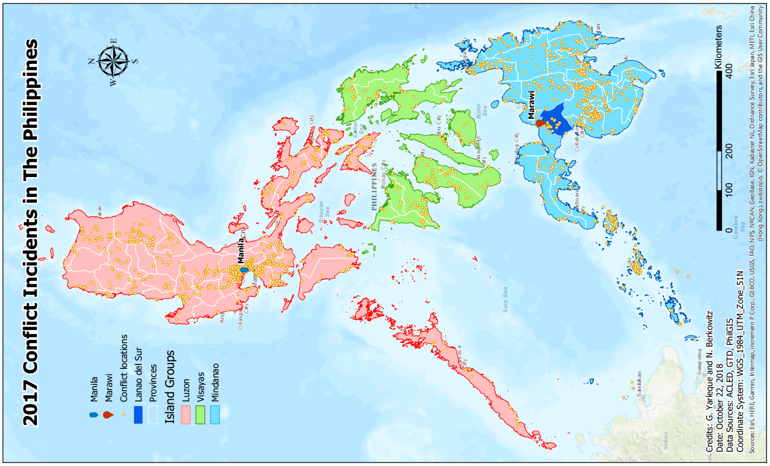
Figure 1: Study area map
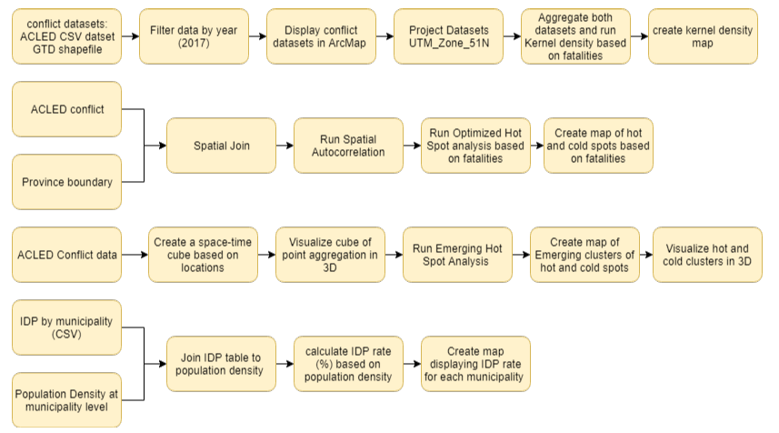
Figure 2: Analysis workflow

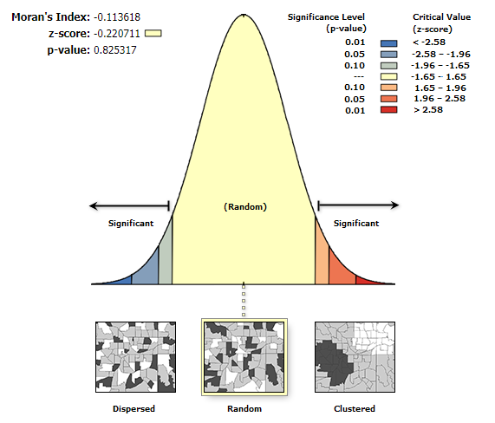
Figure 3: Spatial autocorrelation results
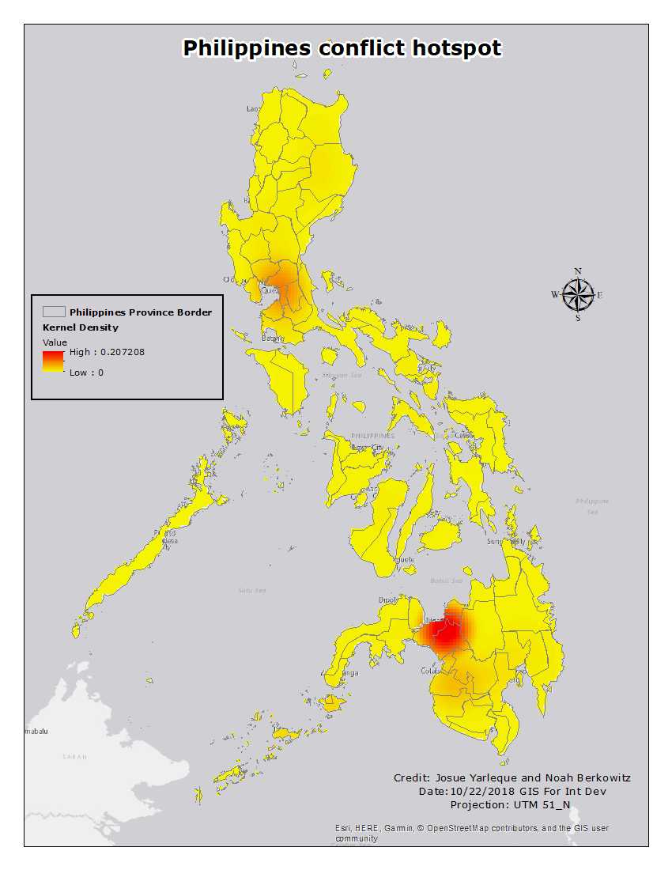
Figure 4: Kernel Density Conflict Map

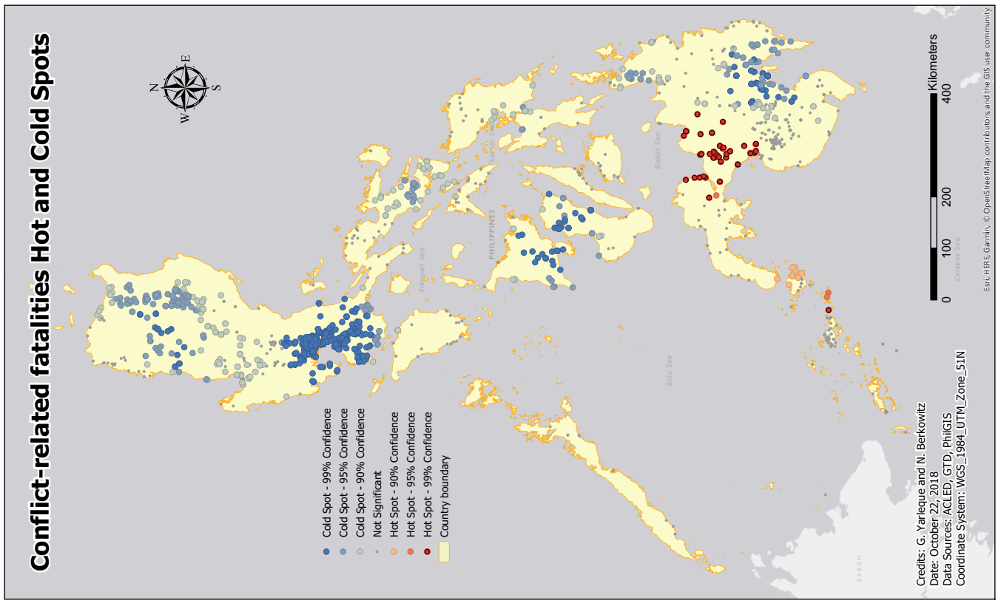
Figure 5: Conflict-related fatalities Hot and Cold spots
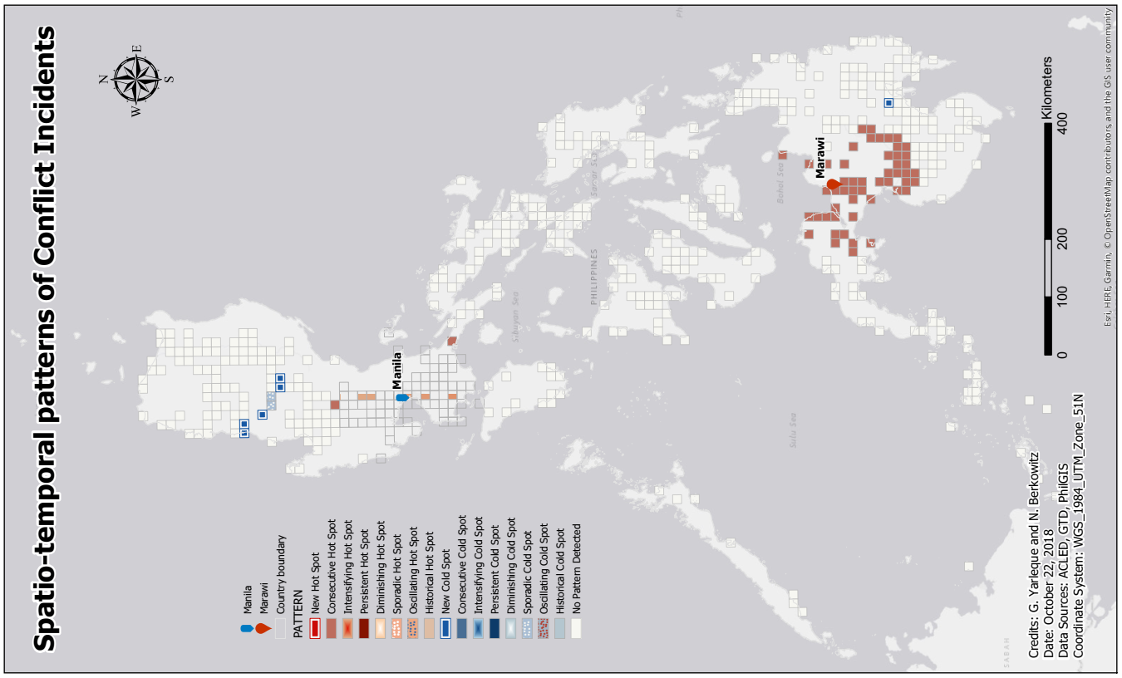
Figure 6: Spatio-temporal patterns of conflic incidents
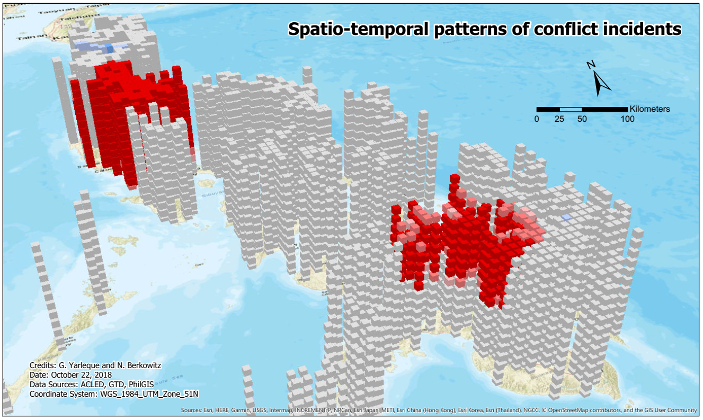
Figure 7: Visualization of conflict occurrence in a three-dimensional space

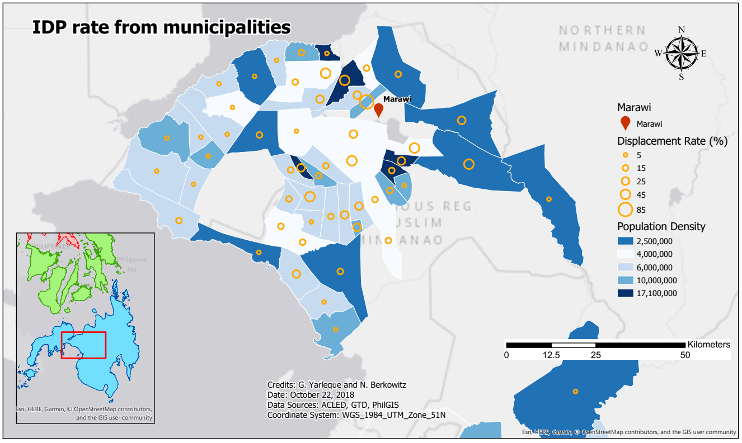
Figure 8: IDP at the municipality level
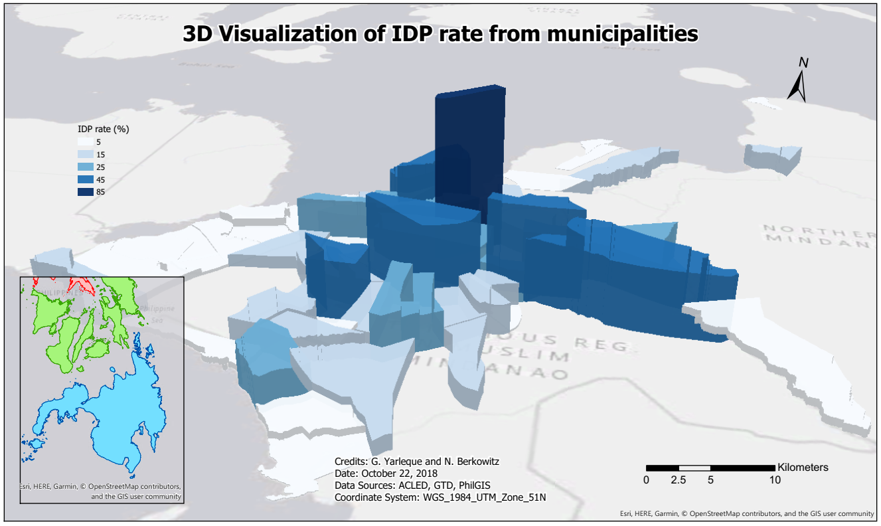
Figure 9: Three-dimensional visualization of IDP displacement rate (%) at the municipality level.

Reference:

Afsar, M., et al., 2014. Spatio-Temporal Analysis of Terrorism Incidents & Law Enforcement Operations in Pakistan (2008-12).
Anon., 2018. What is a z-score? What is a p-value? [online]. ESRI. Available from: http://desktop.arcgis.com/en/arcmap/10.3/tools/spatial-statistics-toolbox/what-is-a-z-score-what-is-a-p-value.htm [Accessed 1 October 2018].
Felter, J., 2018. Philippines Empirical Studies of Conflict [online]. Empirical Studies of Conflict Project, Princeton University. Available from: https://esoc.princeton.edu/country/philippines [Accessed 1 October 2018].
Florance, P., 2017. Calculating the Change in Uganda Conflict Zones [online]. Tufts University Data Lab. Available from: https://sites.tufts.edu/gis/files/2013/11/Uganda-Conflict-Hot-Spot-Analysis-and-Kernel-Denisty_KM_10.4.1.pdf [Accessed 1 October 2018].
Kulldorff, M., 2001. Prospective Time Periodic Geographical Disease Surveillance Using A Scan Statistic.
Levine, N., 2006. Crime Mapping and the CrimeStat Program.
Siebeneck, L., et al., 2009. Spatial and Temporal Analyses of Terrorist Incidents in Iraq, 2004–2006.
Tobler, W. R. 1970. A Computer Movie Simulating Urban Growth in the Detroit Region. Economic Geography, 46(sup1), 234-240.

